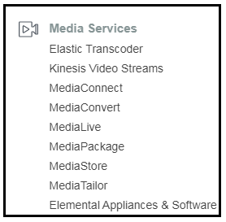 KINESIS   
  
1. What is streaming data : Streaming data is data that is generated continuously by thousands of data sources, Which typically send in the data records simultaneously and in small sizes of Kb.

Examples : Purchases from Amazon stores.  
 Stock Prices.  
 Social networking data.  
 Geospatial data (uber.com)

2. What is Kinesis ?  
Amazon’s Kinesis is a platform to which you send your streaming data to.  
Kinesis makes it easy to load and analyze streaming data.

3. Kinesis Services.  
 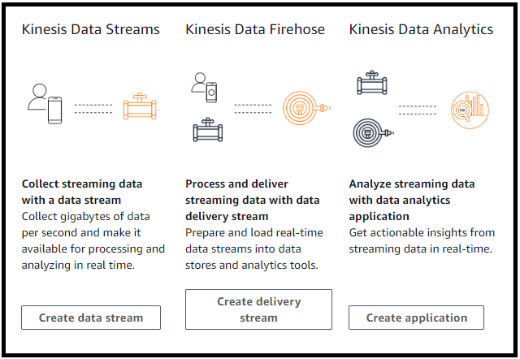  
  
Kinesis Streams :   
  
- Kinesis Streams consists of shards.  
- A Shard gives you 5 transactions per second for read + not exceeding 2MB/sec.  
- A shard also gives you up to 1000 records per second for writes + not exceeding 1MB per second (including partition keys)  
- You can retain data by default from 24 hours(default) to 7 days.  
- the data consumers take the data from the shard and turn it into something useful.  
- After the data consumers have done processing the data, they can send that data to be stored in a variety of aws services like DynamoDB/S3/Elastic Map Reduce/Redshift.  
  
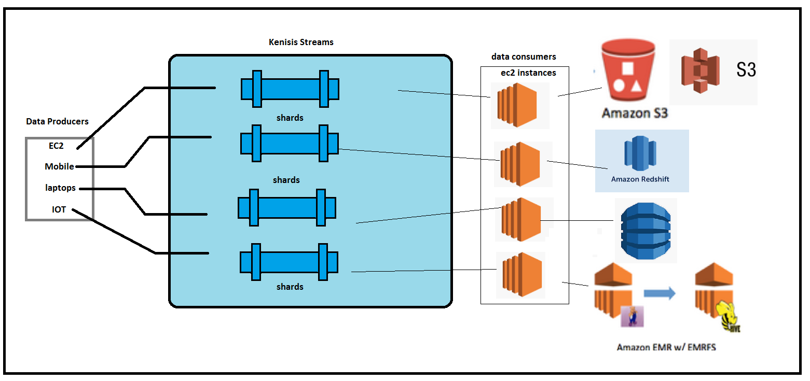  
  
Kinesis Firehose :   
- you don’t have to worry about shards and manually adding shards to keep up with the data.  
- You don’t have to worry about data consumers also.  
- There is no automatic data retention window. As soon as the data comes into Kinesis firehose, it is automatically analyzed using AWS Lambda , Or it is sent directly on to S3 Or other locations like RedShift. If you are sending to RedShift via Firehose, we have to write to S3 first and that data is copied to redshift.  
- You can also send this data to elastic search cluster.  
  
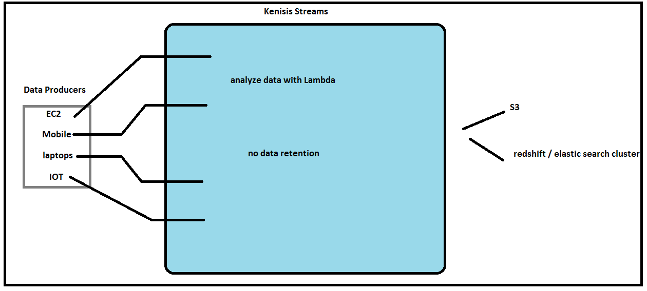  
  
Kinesis Analytics :   
  
- This service allows you to run SQL query of the data, as it exists within ‘firehose’ or ‘streams’.  
- We can store the SQL query result in S3/ Redshift/Elastic Search Cluster.  
- It’s a way of analyzing the data inside Kinesis using SQL.  
  
4. Kinesis LAB using cloud Formation.  
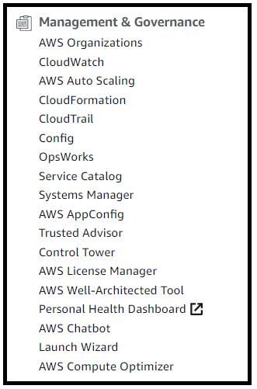 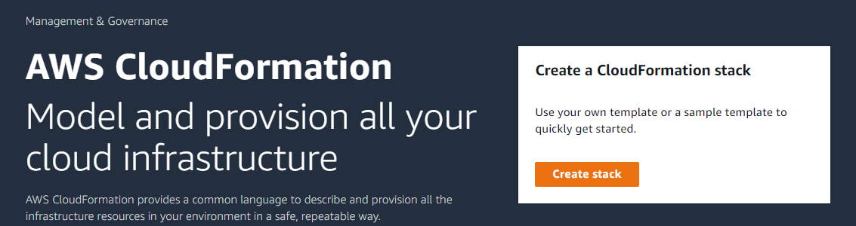  
  
Upload the template to S3.  
  
  
Create a stack.  
